## Reports/ Audit / Controlled Substance Rx Details Report:

Request:

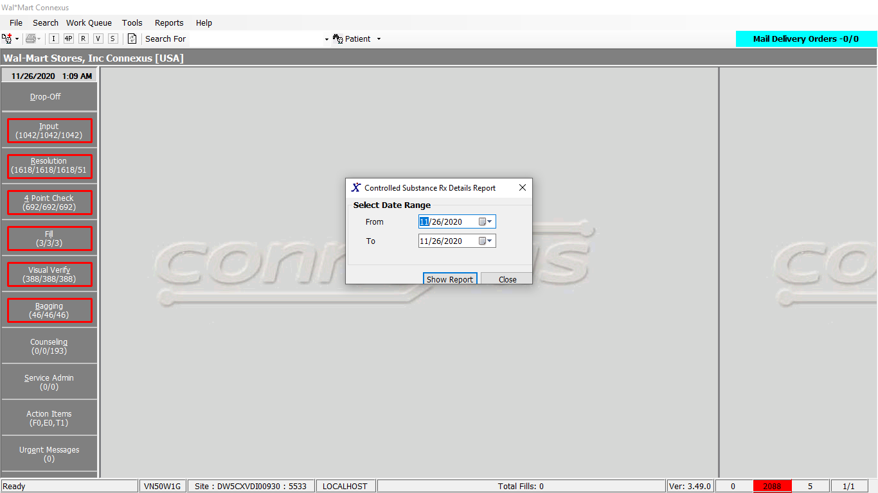

Response:

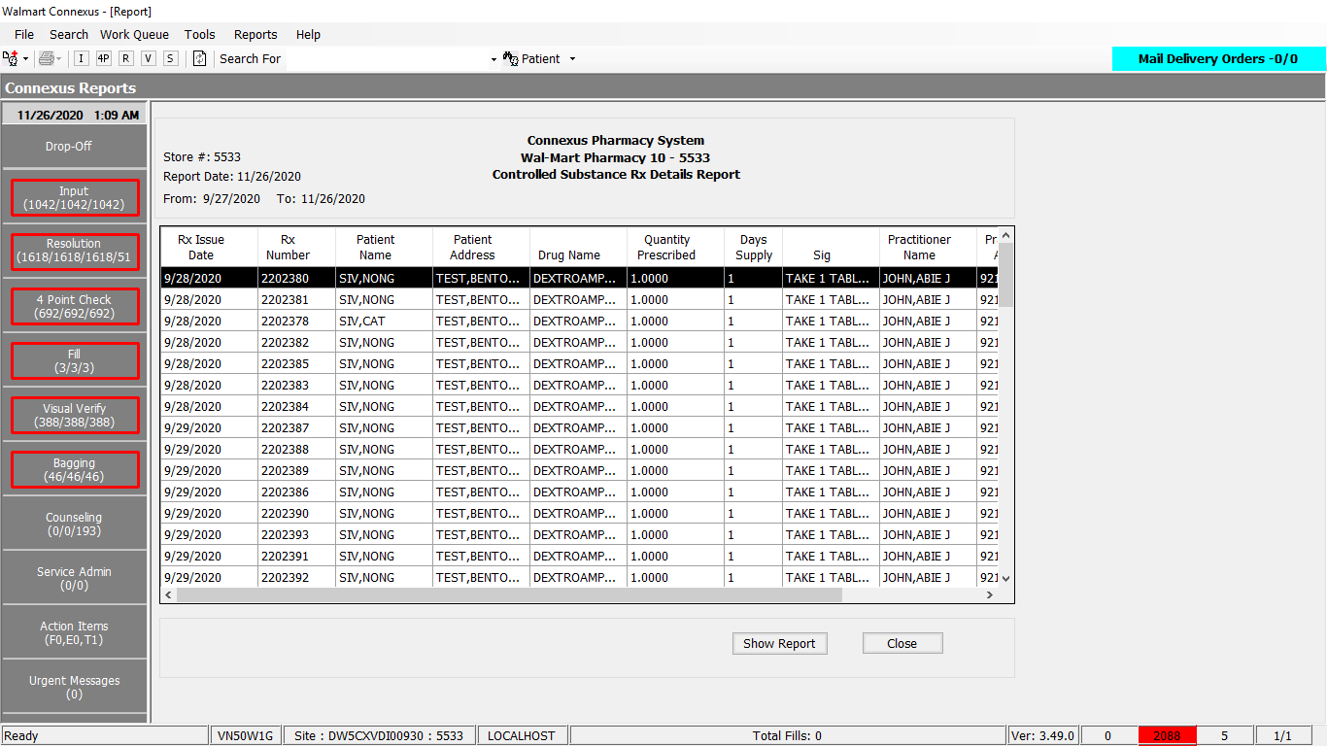

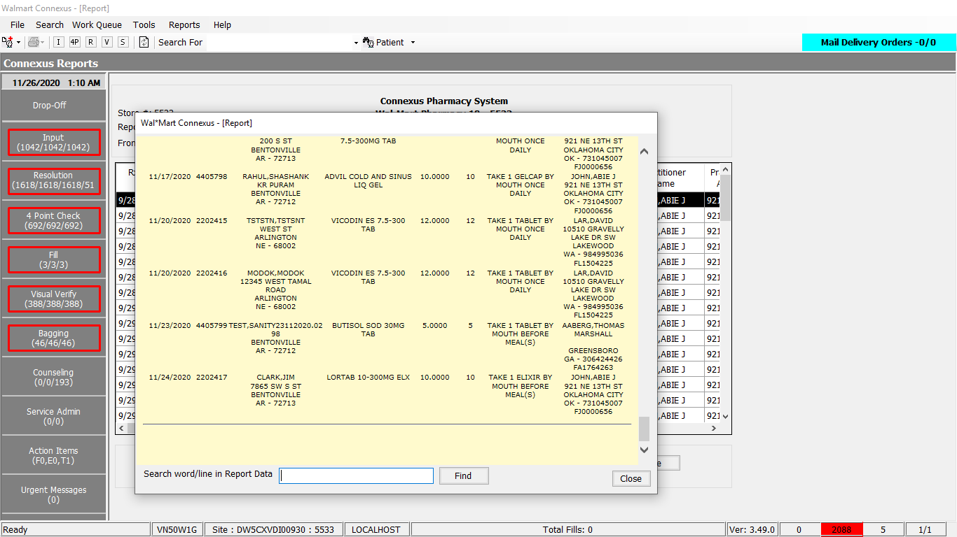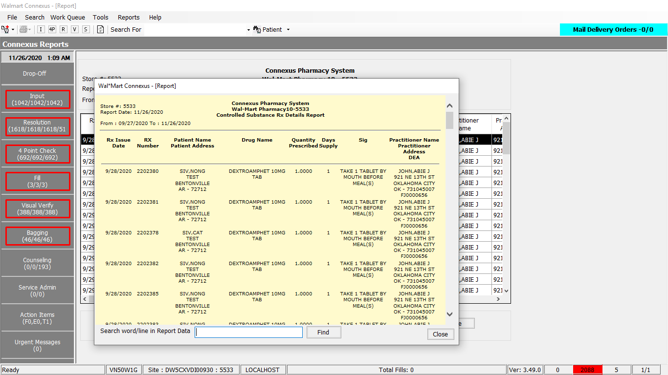

Queries:

1.Public Const GetPrescriptionDetails As String = " SELECT rx.rx_written_date rx_written_date , rx.rx_nbr Rx_Number , rx.fill_days_sply_qty Days_Supply," &

" TRIM(NVL(pat.last_name,'')) || ',' || TRIM(NVL(pat.first_name,'')) " &

" || ' ' || TRIM(NVL(pat.middle_name,'')) Pat_Name , " &

" TRIM(sa.address_line_1) PatAddrLine1," &

" TRIM(sa.city_name) PatCity, TRIM(NVL( sa.state_prov_code,'')) " &

" || ' - ' || sa.postal_code PatStateZip , " &

" pp.short_name Drug_Name , pp.drug_strength_desc Drug_Strength ," &

" dft.disp_dosg_frm_desc Dosage_Form ,rx.fill_qty Pres_Qty , rx.expanded_sig_txt Sig," &

" TRIM(NVL(pr.last_name,'')) || ',' || TRIM(NVL(pr.first_name,'')) " &

" || ' ' || TRIM(NVL(pr.middle_name,'')) Pres_Name," &

" TRIM (sa1.address_line_1) PrsbrAddrLine1," &

" TRIM(sa1.city_name) PrsbrCity, TRIM(NVL( sa1.state_prov_code,''))" &

" || ' - ' || sa1.postal_code PresStateZip " &

",NVL(rpl.license_nbr,pl.license_nbr) DEA" &

" FROM rx , Patient pat , subject_address sa ," &

" pharmacy_offering:pharmacy_product pp, " &

" pharmacy_offering:disp_dosg_form_txt dft , " &

" prescriber pr , rx_fill rf, OUTER prescriber_license pl,subject_address sa1, " &

" rx_prsbr_license rpl" &

" WHERE rx.Patient_id = Pat.Patient_id" &

" AND pat.patient_id = sa.subject_id" &

" AND sa.subject_type_code = 300 " &

" AND rx.product_mds_fam_id = pp.product_mds_fam_id " &

" AND pp.drug_control_code BETWEEN 2300 AND 2303 " &

" AND dft.disp_dosg_form_cd = pp.disp_dosg_form_cd " &

" AND rx.prescriber_id = pr.prescriber_id " &

" AND pr.prescriber_id = pl.prescriber_id " &

" AND pl.license_type_code = 800 " &

" AND sa1.subject_id = rx.clinic_id " &

" AND sa1.subject_type_code = 303 " &

" AND DATE(rx.rx_written_date) BETWEEN ? AND ? " &

" AND rx.status_code NOT IN (20603,20605,20608,20600)" &

" AND rx.prescriber_id = rpl.prescriber_id " &

" AND rx.rx_id = rpl.rx_id " &

" AND rpl.license_type_code = 800 " &

" AND pl.license_nbr = (SELECT MIN(pl1.license_nbr) FROM prescriber_license pl1" &

" WHERE pl1.license_type_code = pl.license_type_code " &

" AND pl.prescriber_id = pl1.prescriber_id " &

" AND (pl1.effective_date >= TODAY OR " &

" pl1.effective_date IS NULL) " &

" AND (pl1.expiration_date is NULL OR " &

" pl1.expiration_date <= TODAY) " &

" AND pl1.status_code = 20006)" &

" AND rx.rx_id = rf.rx_id " &

" AND rf.rx_fill_id = (SELECT MIN(rf1.rx_fill_id) FROM rx_fill rf1 WHERE rf1.rx_id = rf.rx_id And rf1.status_code <> 20403) " &

" AND (((SELECT count(rfa1.activity_code) FROM rx_fill_activity rfa1 WHERE rfa1.rx_fill_id = rf.rx_fill_id " &

" AND rfa1.activity_code = 15116) > 0 And rpl.license_nbr Like 'X%') OR " &

"((SELECT count(rfa2.activity_code) FROM rx_fill_activity rfa2 WHERE rfa2.rx_fill_id = rf.rx_fill_id " &

" AND rfa2.activity_code = 15115) > 0 AND rpl.license_nbr not like 'X%') OR " &

"((SELECT count(rfa2.activity_code) FROM rx_fill_activity rfa2 WHERE rfa2.rx_fill_id = rf.rx_fill_id " &

" AND rfa2.activity_code in (15115,15116)) = 0))" &

" ORDER BY rx.rx_written_date"

2. Public Const GetDateTime As String = "Select CURRENT dtmCurrent FROM systables where tabname = 'systables'"

DAL:

1.Public Function GetPrescriptionDetails(ByVal siteId As Integer, ByVal startDate As Date, ByVal endDate As Date) _

As List(Of GetPrescriptionDetailsBE) Implements IReportDAL.GetPrescriptionDetails

Using (New Tracer(ConnexusCommonConstants.ConnexusTracer))

Dim info As List(Of GetPrescriptionDetailsBE) = Nothing

Dim parameterlist As New List(Of DbParameter)

parameterlist.Add(ParameterHelper.BuildParameter("StartDate", DbType.Date, startDate))

parameterlist.Add(ParameterHelper.BuildParameter("EndDate", DbType.Date, endDate))

Using dr As IDataReader = ExecuteReader(DatabaseEnum.rx21c, siteId, ReportQueries.GetPrescriptionDetails, parameterlist)

While dr.Read

Dim item As New GetPrescriptionDetailsBE

If Not dr.IsDBNull(dr.GetOrdinal("rx_written_date")) Then

item.RxWrittenDate = dr.GetDateTime(dr.GetOrdinal("rx_written_date")).ToShortDateString

End If

If Not dr.IsDBNull(dr.GetOrdinal("Rx_Number")) Then

item.RxNumber = dr.GetInt32(dr.GetOrdinal("Rx_Number"))

End If

If Not dr.IsDBNull(dr.GetOrdinal("Pat_Name")) Then

item.PatName = dr.GetString(dr.GetOrdinal("Pat_Name"))

End If

If Not dr.IsDBNull(dr.GetOrdinal("PatAddrLine1")) Then

item.PatAddrLine1 = dr.GetString(dr.GetOrdinal("PatAddrLine1"))

End If

If Not dr.IsDBNull(dr.GetOrdinal("PatCity")) Then

item.PatCity = dr.GetString(dr.GetOrdinal("PatCity"))

End If

If Not dr.IsDBNull(dr.GetOrdinal("PatStateZip")) Then

item.PatStateZip = dr.GetString(dr.GetOrdinal("PatStateZip"))

End If

If Not dr.IsDBNull(dr.GetOrdinal("Drug_Name")) Then

item.PresDrugName = dr.GetString(dr.GetOrdinal("Drug_Name"))

End If

If Not dr.IsDBNull(dr.GetOrdinal("Pres_Qty")) Then

item.PresQty = dr.GetDecimal(dr.GetOrdinal("Pres_Qty"))

End If

If Not dr.IsDBNull(dr.GetOrdinal("Days_Supply")) Then

item.DaysSupply = dr.GetInt16(dr.GetOrdinal("Days_Supply"))

End If

If Not dr.IsDBNull(dr.GetOrdinal("Sig")) Then

item.Sig = dr.GetString(dr.GetOrdinal("Sig"))

End If

If Not dr.IsDBNull(dr.GetOrdinal("Pres_Name")) Then

item.PresName = dr.GetString(dr.GetOrdinal("Pres_Name"))

End If

If Not dr.IsDBNull(dr.GetOrdinal("PrsbrAddrLine1")) Then

item.PrsbrAddrLine1 = dr.GetString(dr.GetOrdinal("PrsbrAddrLine1"))

End If

If Not dr.IsDBNull(dr.GetOrdinal("PrsbrCity")) Then

item.PrsbrCity = dr.GetString(dr.GetOrdinal("PrsbrCity"))

End If

If Not dr.IsDBNull(dr.GetOrdinal("PresStateZip")) Then

item.PrsbrStateZip = dr.GetString(dr.GetOrdinal("PresStateZip"))

End If

If Not dr.IsDBNull(dr.GetOrdinal("DEA")) Then

item.DEA = dr.GetString(dr.GetOrdinal("DEA"))

End If

If info Is Nothing Then

info = New List(Of GetPrescriptionDetailsBE)

End If

info.Add(item)

End While

End Using

Return info

End Using

End Function

2.Public Shared ReadOnly Property GetDBDateTime(ByVal siteId As Integer) As DateTime

Get

Using (New Tracer(ConnexusCommonConstants.ConnexusTracer))

Dim dbDateTime As DateTime

Dim offset As TimeSpan

Dim isOffsetValid As Boolean

'Get the offset time from cache

isOffsetValid = TimeSpan.TryParse(Convert.ToString(CnxCache(CStr(CacheKeys.OffsetTime))), offset)

If (Not isOffsetValid) Then

'get it from db

'execute query

dbDateTime = CDate(ExecuteScalar(DatabaseEnum.rx21c, siteId, BaseQueries.GetDateTime))

offset = dbDateTime.Subtract(DateTime.Now)

'Add it to Cache

CnxCache.Add(CStr(CacheKeys.OffsetTime), offset, CacheHelper.GetExpirationPolicy(CStr(CacheKeys.OffsetTime)))

End If

Return DateTime.Now.Add(offset)

End Using

End Get

End Property